**Adobe Photoshop Test Notes Chapter 2**

1. Layers are the key to creating and manipulating Photoshop images.
2. The button, CS Live on the Photoshop Application bar accesses CS Live and Acrobat.
3. You cannot calculate project complexity from within Acrobat.com
4. Good, Fast, Cheap are the three ideals that make up the Project Complexity triangle.
5. Metadata is the term for descriptive standardized information about a file, and includes information such as the author’s name, copyright, and keywords associated with it.
6. Project scope is defined as the goals and objectives of a project.
7. Tasks is the project management term used to define specific goals that lead to the ultimate completion of the project.
8. You can make a layer active by clicking its name on the Layers panel.
9. Photoshop records each task you complete in an image on the History panel.
10. By default, transparent areas of an image have a checkerboard display on the Layer’s panel.
11. You do not need an Internet connection to use Photoshop Help.

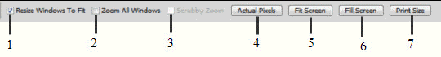

1. In the figure above, figure 7 refers to the button that zooms the window to the print resolution.
2. In the figure above, figure 5 refers to the button that fits the image to the screen.
3. In the figure above, figure 4 refers to the button that displays an image at 100% magnification.
4. The figure above is a portion of the Zoom Tool options bar.
5. Orientation is the direction in which an image appears on a page.
6. You can use the File Info dialog box to identify a file, add a caption or other text, or add a copyright notice.

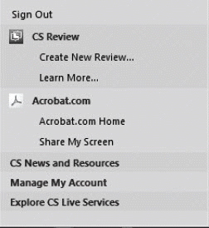

1. CS Live menu is the name of the figure above.
2. You can change the magnification factor of an image using the Navigator panel on the Zoom tool on the Tools panel.

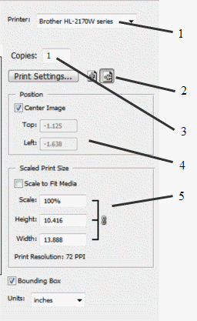

1. In the figure above, figure 1 refers to the selected printer.
2. In the figure above, figure 4 refers to the positioning options.
3. The figure above is a portion of the Print dialog box.
4. In the figure above, figure 5 refers to the scaling options.
5. Proof Setup lets you preview your image to see how it will look when printed on a specific device.

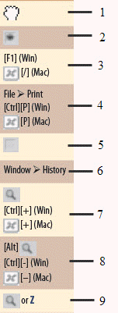

1. In the figure above, figure 3 refers to the power user shortcut for opening Photoshop Help.
2. In the figure above, figure 9 refers to the power user shortcut for opening the Zoom tool.
3. In the figure above, figure 2 refers to the power user shortcut for hiding a layer.